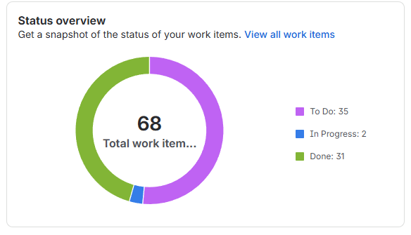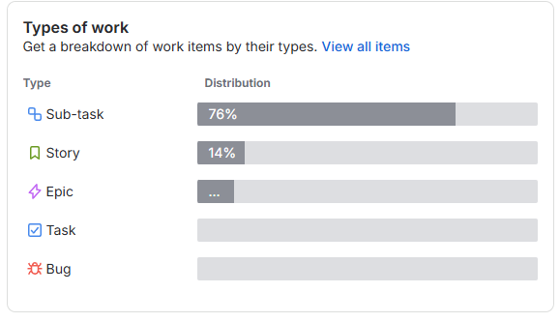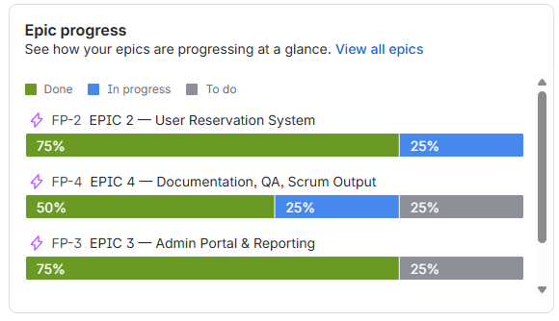
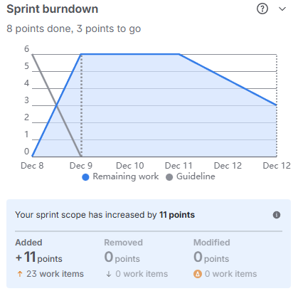

Teams Communication plan
Our team agreed to communicate via discord for most discussion while using email to share important files and git to keep our repository accessible to each member.

Lessons Learned
Our team learned once again about waiting until the last minute and how difficult it can be to coordinate a project among other schedules especially with other homework and projects due at the end of the semester.

Github Repo
https://github.com/aheg7b/IT-4320-Final

